Assignment-3

Give a LAN and WAN Diagrams.Explain about the same in simple words and with an example.

Local Area Network(LAN):

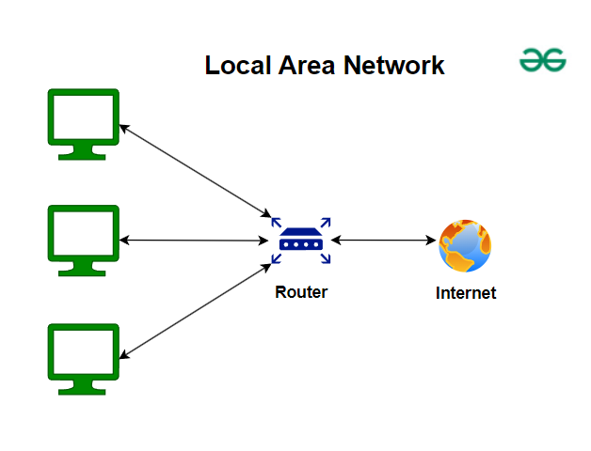

A local area network is a collection of devices connected together in one physical location, such as a building, office, or home.

Example: Home ,Office ,School etc

Wide Area Network(WAN):

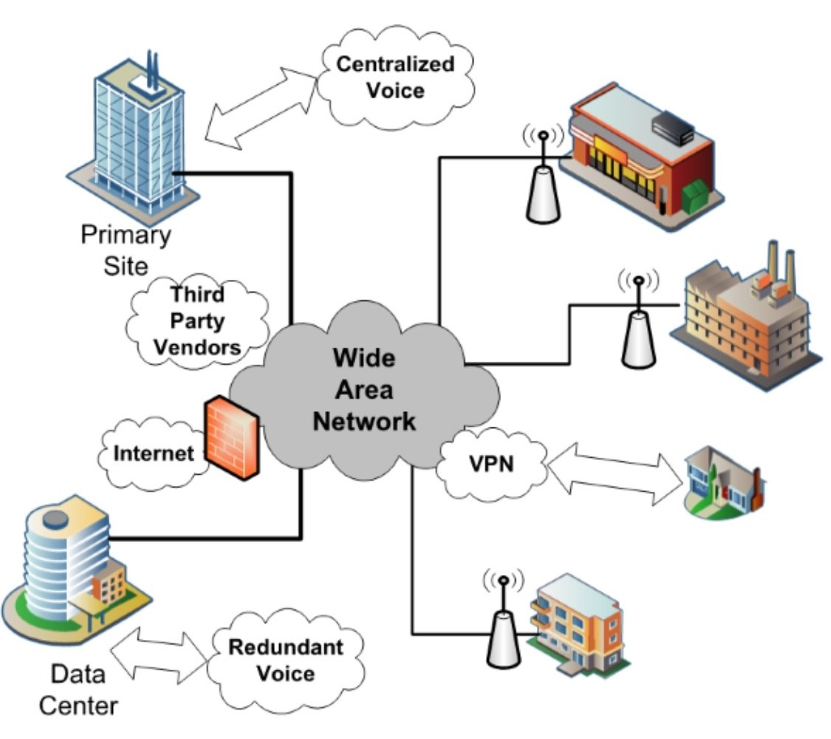

A Wide Area Network (WAN) connects geographically dispersed Local Area Networks (LANs) and devices, spanning larger areas like cities, countries, or even globally.

Examples:

the Internet, corporate networks connecting multiple branch offices, and bank networks connecting ATMs and branches.